The C compiler which has been used is **gcc 4.1.1**

Compile the files using the following commands –

* gcc –g –o At1 Stage1.c –lgen
* gcc –g –o At2 Stage2.c -lgen
* gcc –g –o At3 Stage3.c -lgen

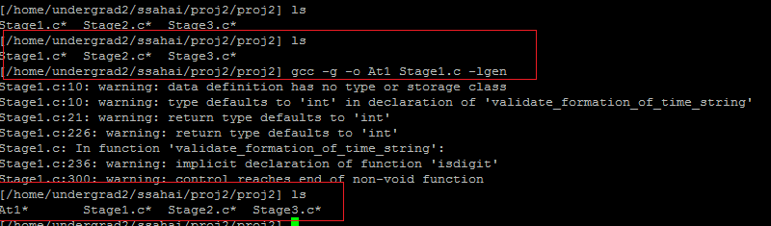

After compiling all the 3 files , the directory has these files-

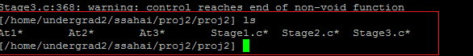

**Output of First Stage –**

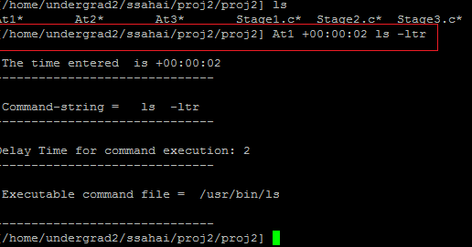

**Output of Second Stage-**

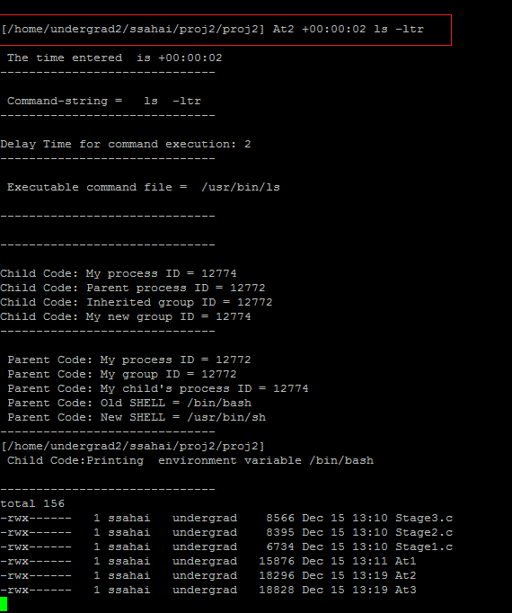

**Output of Third Stage-**

